SQL Date & Time Functions
1. Create and Populate Table
Query:-
CREATE TABLE Employees (
EmpID INT PRIMARY KEY,
Name VARCHAR(50),
DateOfBirth DATE,
JoinDate DATE
);
INSERT INTO Employees (EmpID, Name, DateOfBirth, JoinDate) VALUES
(1, 'Alice Johnson', '1985-05-20', '2010-06-15'),
(2, 'Bob Smith', '1990-08-10', '2015-09-01'),
(3, 'Charlie Brown', '1988-03-25', '2012-11-12'),
(4, 'Diana Prince', '1992-01-30', '2017-07-08'),
(5, 'Eve Adams', '1987-12-05', '2013-03-20');
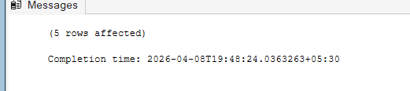
2. SQL Query Tasks
1. a) Current Date & Time: Display the current system date and time.
SQL:
SELECT CURRENT_TIMESTAMP;
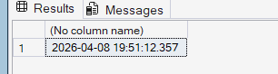

2. b) Calculate Age: Compute each employee’s age in years based on DateOfBirth.
SQL:
SELECT Name,
DATEDIFF(YEAR, DateOfBirth, GETDATE())
- CASE
WHEN DATEADD(YEAR, DATEDIFF(YEAR, DateOfBirth, GETDATE()), DateOfBirth) > GETDATE()
THEN 1
ELSE 0
END AS Age
FROM Employeess;
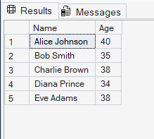

3. c) Calculate Experience: Compute total years of service since JoinDate.
SQL:
SELECT Name,
DATEDIFF(YEAR, JoinDate, GETDATE())
- CASE
WHEN DATEADD(YEAR, DATEDIFF(YEAR, JoinDate, GETDATE()), JoinDate) > GETDATE()
THEN 1
ELSE 0
END AS YearsExperience
FROM Employeess;
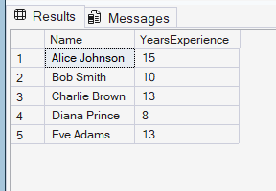

4. d) Extract DOB Components: Extract year, month, and day from DateOfBirth.
SQL:
SELECT Name, YEAR(DateOfBirth) AS BirthYear, MONTH(DateOfBirth) AS BirthMonth, DAY(DateOfBirth) AS BirthDay FROM Employeess;
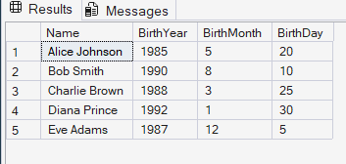

5. e) Born in August: List employees born in the month of August.
SQL:
SELECT Name FROM Employeess WHERE MONTH(DateOfBirth) = 8;
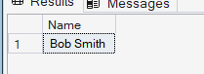

6. f) Upcoming Birthdays: Display names of employees whose birthdays fall in the next 30 days.
SQL:
SELECT Name
FROM Employeess
WHERE
DATEADD(YEAR, DATEDIFF(YEAR, DateOfBirth, GETDATE()), DateOfBirth)
BETWEEN CAST(GETDATE() AS DATE)
AND DATEADD(DAY, 30, CAST(GETDATE() AS DATE));
